**Chapter -0**

**Introduction to CSS**

# Chapter -0 Introduction:

Html is just a selector layout of a websites. He needs CSS to design a websites and styles to it and make it look beautiful.

**But Web Design Used language HTML, CSS and JavaScript Definition of this types**.

* HTML is used as a **standard language for any website design**. It acts as a static skeleton to a web application. It’s a well-standardized system.
* CSS is used to **handle the presentation of the web page**. It makes the website look **attractive and beautiful.**
* JavaScript allows **scripting on your website and makes it completely dynamic in nature**. It provides front end scripting for your website and **is a high-level dynamic interpreted programming language.**

Let’s being start now According to this course:

# What is CSS

* CSS stands for creating style sheets in Html docs.
* CSS is optimal but it creates an off looking HTML page into a beautiful and responsive website.

# Installing Vs Code

We will use Microsoft visual studio code as a tool to edit our code. It is very powerful and free of cost tool.

# Why Learn CSS

CSS is very demanded skill in the world of web development. If you are successful able to master in CSS you can customise your website ad per your liking.

# Your First line of CSS

Create a CSS file inside your directory and add it to your HTML. Add the following line to your CSS.

Actually, we can learn add CSS code in HTML file manly three types learn in next chapter.

<!DOCTYPE html>

<html lang="en">

<head>

    <title>Change BgColor</title>

    <style>

        body{

            background-color: blue;

            color: brown;

        }

    </style>

</head>

<body>

    <div>

        <h2>

            In thid page only Change background-color using css throw

        </h2>

    </div>

</body>

</html>

# Html Reference:

* HTML is a branch of tags used to layout the structure of a page.
* We Can also watch a basic HTML learn of TUTORIAL on my Website LINK :
* TUTORIAL OF HTML

**Chapter 1**

**(Creating Our First CSS Websites)**

**Chapter -1 Introduction**

Hi, In This Chapter we will create first CSS Websites.

# What is DOM

DOM stands for **Document Object Model**. When a page loaded, the browser creates a DOM of the page which is constructed is tree of Object.

# HTML Id and class attributes:

* When an HTML element is given an id, It serves as **a unique identifiers** for that elements.
* On the other hand, when a HTML element is given class, it now belongs to that class. More than one elements is belongs for the single class but every elements must have a unique id( if assigned).
* We can add multiple classes to an element like this.

<div id= ‘first’ class= ‘C1 C2 C3’>

</div>

Here: - #first is the unique id

C1, C2, and C3 are the multiple classes

Followed by spaces

**There are three ways to add CSS code in HTML Page.**

* Style Tags: Adding <style> ……… < /style> to HTML
* Inline Tags: Adding CSS unique style attributes
* External CSS: Adding a stylesheet(.css) to HTML using <link> tag in HTML Page.
* Let’s see Examples of details.

# CSS Selector:

A CSS Selectors is used to select an HTML element for styling.

For Example

**#body is a CSS selector**

# Element Selector:

**It is used select an element based on the tag name**

For Example:

# Id Selector:

* **It is used to select an element with a given id.**

For Example: -

# Class Selector: -

**It is used to select an element with a given class.**

For Example: -

# Important Selector:

* **We can use group selectors like this.**
* h1,h2,p{
* color: rgb(37, 37, 19);
* }
* **We can use element class as a selector like this.**
* **Can be used as a universal selector to selectors all the elements.**
* **An Inline style will override external and internal styles.**

# Comments in CSS:

**Comments in CSS are the which is not parsed and is thus ignored.**

For Example1:

1st Line Of Comments:

    /* background-color: blue; */

Multiline of Comments:

/* .bg-blue{

    background-color: blue;

    color: white;

} */

**Chapter -1 Practice Set**

Q1. Create a website with a class red div which has a background colour of red and colour.

Q2. Create an element with id head and verify that background colour works on it as inline, creates as well using style tag CSS.

Q3. Create a CSS class one and verify that it works a multiple element.

Q4. Create multiple CSS class and verify that all of there works on the same elements.

Q5. There a look at the MDN CSS reference and try to play around with few key- value CSS rules.

**Chapter 2**

**(Colours and Background)**

# Chapter 2 Introduction:

**CSS rules are simple key-values pairs with a selectors, We can write CSS rules to changes colour and set background.**

## The Colours Property:

* The CSS colours property can be used to set the test colours inside an element.

p{

color: red; /*Just change your font color red.*/

}

* Similarly we can set color for different elements

## Types of color values :

Following are the most commonly used color values **in CSS.**

1. RGB: Specify color using **RGB (RED+GREEN+BLUE**)values.

Example: rgb(0, 0, 255);

1. HEX Code: Specify color **using hex (Hexa-Decimal)code.**

Example: #3f5d7c;

1. HSL Specify the color using **HSL(Hue Saturation Lightness** ) values.

Example: hsl(0, 59%, 41%);

1. The values of the color or background is provided as any one of these values.

**NOTE: We also an RGBA and HSLA values for color but they are used by bigneers a stands for ALPHA(0 means color, 1 means DARK ).**

## The Background-color Property:

* CSS background-color property specify the background color of a container.
* We are already discuss about Background color in privous chapter1 and practice set.
* FOR EXAMPLE:

<style>

        h1{

            background-color: brown;

        }

</style>

* We can use brown place another name of color.

## The Background-Image Property:

* Used to set an image as the background

body{

            background-image: url('bg.jpg');

            background-repeat: no-repeat;

or repeat-x;

or repeat-y;

}

The image as background default repeated in x and y direction

## Property:

* **Repeat-X:** Repeat in Horizontal
* **Repeat-Y:** Repeat in Vertical
* **No -repeat:** No Repeat
* More repat property can we visit the MDN reference

## The Background-Size Property:

Can be following the property:

* Cover : Fits and no empty space remains.
* Contains: Fits and image is full visible.
* Auto: Displays in Original Size.
* {{Width}} : Set width and height will be set automatically
* {{Width:, Height}}: Set Width and Height.

Note: Always Check the MDN document a given CSS property remember, practice, will make you perfect.

## The Background-Position Property:

* Sets the starting position of a background image.

        Div1{

            background-position: center top;

        }

## The Background-attachment Property:

* Defines a scrollable/ Non-scrollable characters of a background image

        Div2{

            background-attachment: fixed;

        }

## The Background-shorthand Property:

* A Single property to set multiple background properties

        Div3{

 background: rgb(83, 5, 5) url("bg.jpg") 30px 40px no-repeat scroll;

        }

* In these properties we can show multiple properties in only one line.
* On of the properties can be missing given the others are in order.

**Chapter -2 Practice Set**

**Q1. Create a dark-blue navigation bar with light color items.**

**Q2. Change the color of the main container on year page to dark-red.**

**Q3. Create a div and add a background image with a given width and height.**

**Q4. Create a vertical bar and odd a fixed non scrolling background to it.**

**Q5. Verify that the background shorthand properties work with same of the values skipped.**

**Chapter 3**

**(CSS Box Model)**

# Box Model Setting padding - margin

* The CSS box model looks at all the HTML element as boxes.

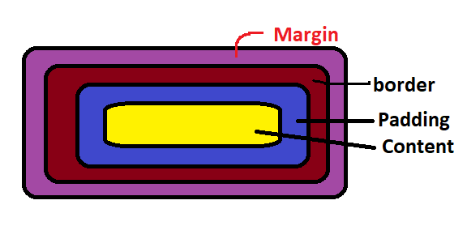

## Setting width and Height

* We can set width and height in CSS as follows.

#box{

    height: 456px;

    width: 466px;

}

Note : That the total width/height is as calculated as follows:

Total height = height + top/ button padding + top/ buttons border + top / bottom margin.

## Setting Margin and Padding

* We can set margin and padding as follows:
* This is default setting of padding and margin.

.box{

    margin: 58px; // sets top, bottom, left and right radius.

    padding: 90px;

    border: 5px red solid;

}

* We can also use one line in box model.

/* margin: 58px; */

    margin: 30px 14px 30px 15px;

         /* top, right, bottom, left  Working on clock-wise */

Or

Margin: 7px 10px;

Top & bottom left&right

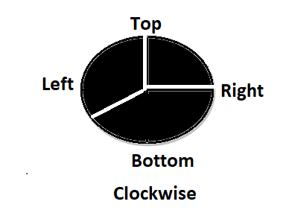

* We can also set individual margin / padding like this:

margin-top: 7px;

    margin-right: 10px;

    margin-bottom: 11px;

    margin-left: 9px;

* It means that we can **use some as padding** methods.

## Setting Borders:

We can set the border as follows:

#boxmodel{

    border-width: 10px;

    border-style: 8px;

    border-color: blueviolet;

Or

    border: 5px rgb(29, 13, 13) solid;  /* just set shorthand type*/

}

## Setting Borders-Radius:

* We can set border radius to create rounded borders

#boxmodel{

border-radius: 150px;

}

# Margin Collapse:

* When two margin from different element overlap the equivalent margin is the greater of the two. This is called Margin Collapse.
* Let’s see a diagram:

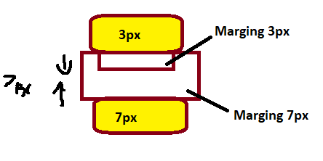

* Margin between then is collapsed to the bigger margin.

# Box- Sizing:

* Determines what out of padding and border is included in elements width and height.
* Can be content – box or border – box.
* Include only content in width height.

.box2{

            box-sizing: border-box;

        }

* This content width and height include content +padding +borders.

**Chapter -2 Practice Set**

**Q1. Create a website layout add a header box, 1 content box and or footer.**

**Q2. Add Border and & Margin to 1.**

**Q3. Did the margin collapse between content box & footer?**

**Q4. Add the box-sizing property to content box what changes did you notice.**

**Chapter 4**

**(Font and Display)**

## The Display Property:

## The Display Property:

* The CSS display is used to determine whether an element is treated as a block/inline element & the layout used for its children.
* Children > Flexbox/ grid etc.

## Displays Inline:

* Tasks only the space required by the element.
* No line tracks before and after width/ height(margin/ padding) not allowed.

## Display Block:

* Takes full space available in width and leaves a newline before and after the element.

## Display: Inline- block:

* Similar to inline but setting height, width, margin and padding is allowed. Element can sit next to each other.

## Displays: None Vs Visibly: Hidden:

* Width display: none , the element is removed from the document flow its space is not blocked.
* With visible: hidden, the element is hidden bit its space is reversed.

## Text – algin property:

* Used to sit horizontal alignment of a text.

Div1{

text-align: Center;

}

## Text – Decoration property:

Used to decorate the text

Can be overline, line- trough, underline, none

## Text – Transform property:

* Used to specify uppercase and lowercase letter in a text.

    p.uppercase{

        text-decoration: uppercase ;

    }

## Line – height property:

* Used to specify the space between line.

.small{

    line-height: 0.7 ;

}

## Font:

Font plays a very important role in the took and feel of a website.

## Font- Family:

Font Family specific the font of a text.

Can hold multiple value as a “Followback” system

P{

Font- family : “Time new roman ” , monospace;

// Always do this to ensure the correct of your choice is rendered.

}

## Web Safe Fonts:

These fonts are universally installed cross browsers.

## How to add Google Fonts:

In order to use custom, google fonts, go to google fonts then select a style and finally paste if to the style.css of your page.

## Other Fonts Properties:

Some of the font properties are listed below:-

**Font-size** : Sets the size of the font

**Font-style:** Setsthe font style

**Font-variant:** Sets the whether text is displayed in small-caps

**Font-Weight:** Sets the weight of the font.

## Generic Families:

Board class of similar font Ex: serif, sans-serif, just like when we say fruit, it can be any fruit when we say serif it can be any serif font.

Font-family: --- Specific

Generic- family—Generic

**Chapter- 4 Practice Set**

**Q1. Create the following websites layout.**